
Department of BES-1
DATA STRUCTURES USSING PYTHON
I/IV-B.Tech-(II Sem), Academic Year: 2024-2025

Session-31 ( Heap Sort )
Instructional Objective:
- To learn the concept of Heap Sort
- To implement Heap Sort in C Programming Language

Learning Outcomes:
- Able to implement heap sort
- Able to analyze time complexities of heap sort

Introduction:
Heap sort processes the elements by creating the min-heap or max-heap using the elements of the given array. Min-heap or max-heap represents the ordering of array in which the root element represents the minimum or maximum element of the array.

Heap sort basically recursively performs two main operations -
- Build a heap H, using the elements of array.
- Repeatedly delete the root element of the heap formed in 1st phase.

Explanation:

What is a heap?
A heap is a complete binary tree, and the binary tree is a tree in which the node can have the utmost two children. A complete binary tree is a binary tree in which all the levels except the last level, i.e., leaf node, should be completely filled, and all the nodes should be left-justified.

What is heap sort?
Heap sort is a popular and efficient sorting algorithm. The concept of heap sort is to eliminate the elements one by one from the heap part of the list, and then insert them into the sorted part of the list.

Types of Heap Data Structure
Heaps can be of two types:
- Max-Heap: In a Max-Heap the key present at the root node must be greatest among the keys present at all of it’s children. The same property must be recursively true for all sub-trees in that Binary Tree. The value of each node is greater than or equal to the value of its parent, with the minimum value at the root.

- Min-Heap: In a Min-Heap the key present at the node must be minimum among the keys present at all of it’s children. The same property must be recursively true for all sub-trees in that Binary Tree. The value of each node is less than or equal to the value of its parent, with the maximum value at the root.

A Binary Heap is a Binary Tree with following properties.
1) It’s a complete tree (All levels are completely filled except possibly the last level and the last level has all keys as left as possible). This property of Binary Heap makes them suitable to be stored in an array.

2) A Binary Heap is either Min Heap or Max Heap. In a Min Binary Heap, the key at root must be minimum among all keys present in Binary Heap. The same property must be recursively true for all nodes in Binary Tree. Max Binary Heap is similar to Min Heap.

A Heap is a special Tree-based data structure in which the tree is a complete binary tree
Operations of Heap Data Structure:
- Heapify: a process of creating a heap from an array.
- Insertion: process to insert an element in existing heap time complexity O(log N).
- Deletion: deleting the top element of the heap or the highest priority element, and then organizing the heap and returning the element with time complexity O(log N).
- Peek: to check or find the most prior element in the heap, (max or min element for max and min heap).

Definition: A binary heap is a Complete Binary Tree where items are stored in a special order such that value in a parent node is greater (Max Heap or smaller Min Heap) than the values in its two child nodes.​
- A complete binary tree is a binary tree in which all the levels are completely filled except possibly the lowest one, which is filled from the left.​
- Heap divided into two types
- Max heap and min heap
- Max heap is root is large when compared to children.
- Min heap is root is smaller when compared to children.
Applications:
• Heaps have an average time complexity of O(log n) for inserting and deleting elements, making them efficient for large datasets.
• Heaps can be implemented as either a max-heap or a min-heap, making them flexible to use for different types of applications, such as priority queues or sorting algorithms.
Heap Construction:
Step 1: Create a new node at the end of heap.
Step 2: Assign new value to the node.
Step 3: Compare the value of this child node with its parent
Step 4: If value of parent is less than child, then swap them
Step 5: Repeat step 3 & 4 until Heap property holds.

Heap sort is the in-place sorting algorithm.
Now, let's see the algorithm of heap sort.

Working of Heap sort Algorithm
Now, let's see the working of the Heap sort Algorithm.
In heap sort, basically, there are two phases involved in the sorting of elements. By using the heap sort algorithm, they are as follows -
- The first step includes the creation of a heap by adjusting the elements of the array.
- After the creation of heap, now remove the root element of the heap repeatedly by shifting it to the end of the array, and then store the heap structure with the remaining elements.
Now let's see the working of heap sort in detail by using an example. To understand it more clearly, let's take an unsorted array and try to sort it using heap sort. It will make the explanation clearer and easier.
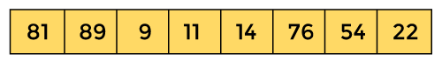
First, we have to construct a heap from the given array and convert it into max heap.
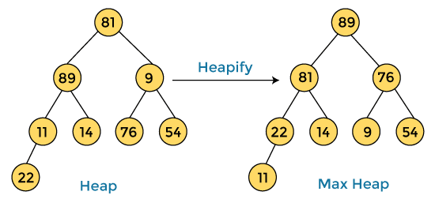
After converting the given heap into max heap, the array elements are -
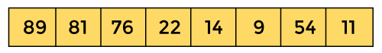
Next, we have to delete the root element (89) from the max heap. To delete this node, we have to swap it with the last node, i.e. (11). After deleting the root element, we again have to heapify it to convert it into max heap.
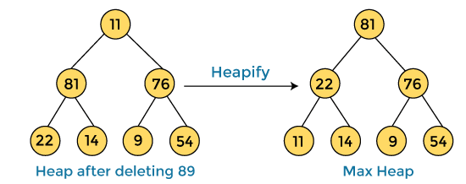
After swapping the array element 89 with 11, and converting the heap into max-heap, the elements of array are -
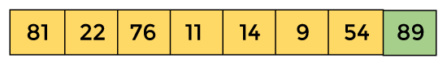
In the next step, again, we have to delete the root element (81) from the max heap. To delete this node, we have to swap it with the last node, i.e. (54). After deleting the root element, we again have to heapify it to convert it into max heap.
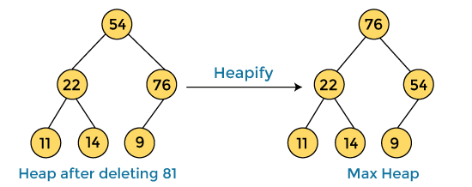
After swapping the array element 81 with 54 and converting the heap into max-heap, the elements of array are -
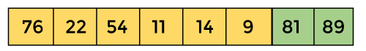
In the next step, we have to delete the root element (76) from the max heap again. To delete this node, we have to swap it with the last node, i.e. (9). After deleting the root element, we again have to heapify it to convert it into max heap.
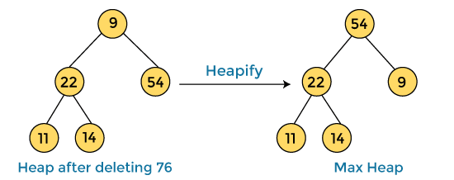
After swapping the array element 76 with 9 and converting the heap into max-heap, the elements of array are -
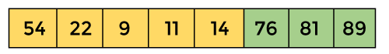
In the next step, again we have to delete the root element (54) from the max heap. To delete this node, we have to swap it with the last node, i.e. (14). After deleting the root element, we again have to heapify it to convert it into max heap.
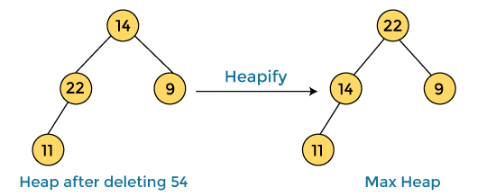
After swapping the array element 54 with 14 and converting the heap into max-heap, the elements of array are -
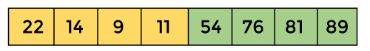
In the next step, again we have to delete the root element (22) from the max heap. To delete this node, we have to swap it with the last node, i.e. (11). After deleting the root element, we again have to heapify it to convert it into max heap.
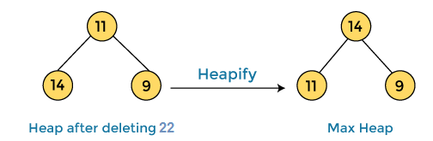
After swapping the array element 22 with 11 and converting the heap into max-heap, the elements of array are -
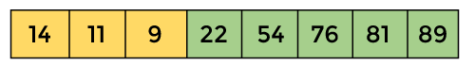
In the next step, again we have to delete the root element (14) from the max heap. To delete this node, we have to swap it with the last node, i.e. (9). After deleting the root element, we again have to heapify it to convert it into max heap.
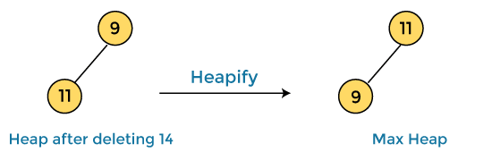
After swapping the array element 14 with 9 and converting the heap into max-heap, the elements of array are -
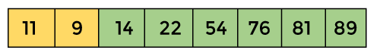
In the next step, again we have to delete the root element (11) from the max heap. To delete this node, we have to swap it with the last node, i.e. (9). After deleting the root element, we again have to heapify it to convert it into max heap.
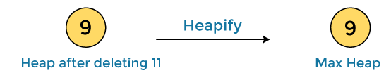
After swapping the array element 11 with 9, the elements of array are -
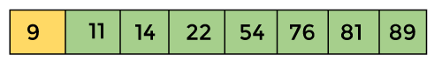
Now, heap has only one element left. After deleting it, heap will be empty.
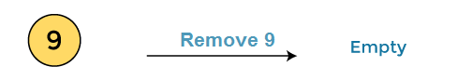
After completion of sorting, the array elements are -
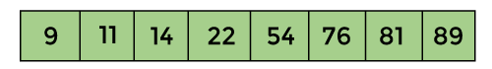
Now, the array is completely sorted.
Heap sort implantation in python
def heapify(arr, n, i):
largest = i # Initialize largest as root
left = 2 * i + 1 # Left child index
right = 2 * i + 2 # Right child index

# Check if left child exists and is greater than root
if left < n and arr[left] > arr[largest]:
largest = left

# Check if right child exists and is greater than root
if right < n and arr[right] > arr[largest]:
largest = right

# If largest is not root, swap and continue heapifying
if largest != i:
arr[i], arr[largest] = arr[largest], arr[i] # Swap
heapify(arr, n, largest) # Recursively heapify the affected subtree

def heap_sort(arr):
n = len(arr)
# Build a max-heap
for i in range(n // 2 - 1, -1, -1):
heapify(arr, n, i)

# Extract elements from the heap one by one
for i in range(n - 1, 0, -1):
arr[i], arr[0] = arr[0], arr[i] # Swap root (max) with the last element
heapify(arr, i, 0) # Rebuild the heap with reduced size
# Example usage
arr = [12, 11, 13, 5, 6, 7]
print("Unsorted array:", arr)
heap_sort(arr)
print("Sorted array:", arr)

OUTPUT :
Unsorted array: [12, 11, 13, 5, 6, 7]
Sorted array: [5, 6, 7, 11, 12, 13]

Applications of Heaps:

1) Heap Sort: Heap Sort uses Binary Heap to sort an array in O(nLogn) time.
2) Priority Queue: Priority queues can be efficiently implemented using Binary Heap because it supports insert(), delete() and extractmax(), decreaseKey() operations in O(logn) time. Binomial Heap and Fibonacci Heap are variations of Binary Heap. These variations perform union also efficiently.
3) Graph Algorithms: The priority queues are especially used in Graph Algorithms like Dijkstra’s Shortest Path and Prim’s Minimum Spanning Tree.

Heap sort complexity
Now, let's see the time complexity of Heap sort in the best case, average case, and worst case. We will also see the space complexity of Heapsort.

1. Time Complexity
Case | Time Complexity
Best Case | O(n logn)
Average Case | O(n log n)
Worst Case | O(n log n)

Best Case Complexity - It occurs when there is no sorting required, i.e. the array is already sorted. The best-case time complexity of heap sort is O(n logn).
Average Case Complexity - It occurs when the array elements are in jumbled order that is not properly ascending and not properly descending. The average case time complexity of heap sort is O(n log n).
Worst Case Complexity - It occurs when the array elements are required to be sorted in reverse order. That means suppose you have to sort the array elements in ascending order, but its elements are in descending order. The worst-case time complexity of heap sort is O(n log n).
The time complexity of heap sort is O(n logn) in all three cases (best case, average case, and worst case). The height of a complete binary tree having n elements is logn.

2. Space Complexity
Space Complexity | O(1)
Stable | N0
- The space complexity of Heap sort is O(1).

Implementation of Heapsort
Now, let's see the programs of Heap sort in different programming languages.

Review questions:
- What is Heap Sort? Explain the method involved in Heap Sort.
- Write a C program Implementation of the Heap Sort.
- Analyze the Time Complexity and Space Complexity of Heap Sort.
Summary:
In this session, it was discussed about the method of Heap Sort. We have implemented the Heap Sort in C Programming Language. We have analyzed the Time Complexity and Space Complexity of the same.

